LSD (Least-significant-digit-first) String Sort

* Consider characters from right to left
* Stably sort using dth character as the key (using key-indexed counting)

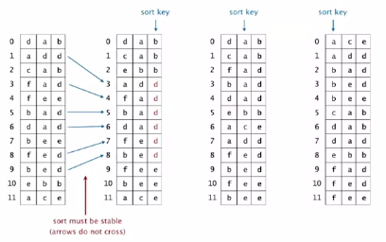

Proposition: LSD sorts fixed-length strings in ascending order

Proof: [by induction on i]

After pass i, strings are sorted by last i characters

* If two strings differ on sort key, key-indexed sort puts them in proper order
* If two strings agree on sort key, stability keeps them in proper relative order

LSD string sort Java implementation

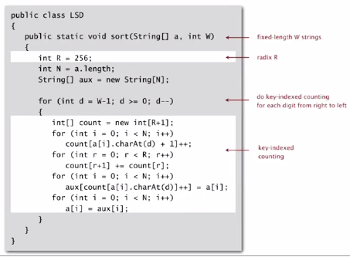

Performance (linear time overall, stable)

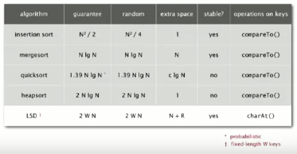

*String sorting interview question:* Sort one million 32-bit integers

Best sorting method?

Insertion sort? Mergesort? Quicksort? Heapsort? **LSD string sort?**